Administrative Office of the U.S. Courts
Department of the CIO / Product Development Office

CM/ECF
Cross-Document Hyperlinks Functionality for Public Filers in NextGen Appellate, Bankruptcy, and District Releases 1.8 and Higher

July 2026

Table of Contents

1. Cross-Document Hyperlinks Overview 1
Highlights of the cross-document hyperlink functionality 1
General assumptions 1
2. Creating Hyperlinks to Documents Already in the Electronic Case 2
3. Creating Hyperlinks between Documents Filed in the Same Event 4

Update Summary
Date | Section | Change
July 2026 | All | Created a new document for release versions 1.8 & higher.

1. Cross-Document Hyperlinks Overview
CM/ECF users can file a document that includes a hyperlink to another document in the same case or another case that resides on the CM/ECF system where the filing is being entered, or on any other court’s CM/ECF system.

Highlights of the cross-document hyperlink functionality
- The hyperlink may link to the start of the document or to a specific page in the document.
- A filer can include a hyperlink to a previously filed document or one that is being filed simultaneously in the same docketing transaction (e.g., a Memo in Support of Summary Judgment may have hyperlinks to document attachments filed in the same entry).
- Immediately after a document is filed in CM/ECF, it is available to be linked in a subsequently filed document.
- Any hyperlink to a CM/ECF document will be retained if the case remains in the primary CM/ECF database.

General assumptions
- Any document that includes a hyperlink must also include the standard citation to the hyperlinked material. The hyperlink is a convenience, not a citation replacement.
- The ability to file documents with hyperlinks to external URLs (e.g., Westlaw, Lexis) is not affected by this functionality.
- The CM/ECF application will not verify the validity of URLs included as hyperlinks within filed documents.

2. Creating Hyperlinks to Documents Already in the Electronic Case
A link can be made to another document in any database in the federal courts: District, Bankruptcy, and/or Appellate.

Important: Do not copy hyperlinks from a Notice of Electronic Filing (NEF) or Notice of Docket Activity (NDA) email. NEF/NDA hyperlinks contain special “one free look” tokens for NEF recipients. Instead, run the Docket Report in CM/ECF and copy the document number hyperlink from there.

Step-by-Step Example using Microsoft Word and Adobe Acrobat:
- Access CM/ECF and run the Docket Report for the case containing the document you want to link to.
- Locate the document among the docket entries.
- Copy the URL: hover over the document link or icon, right-click, and select the browser’s copy link action -- e.g., Copy Link (Microsoft Edge, Firefox), Copy Link Address (Chrome).

District or Bankruptcy – Docket Report.
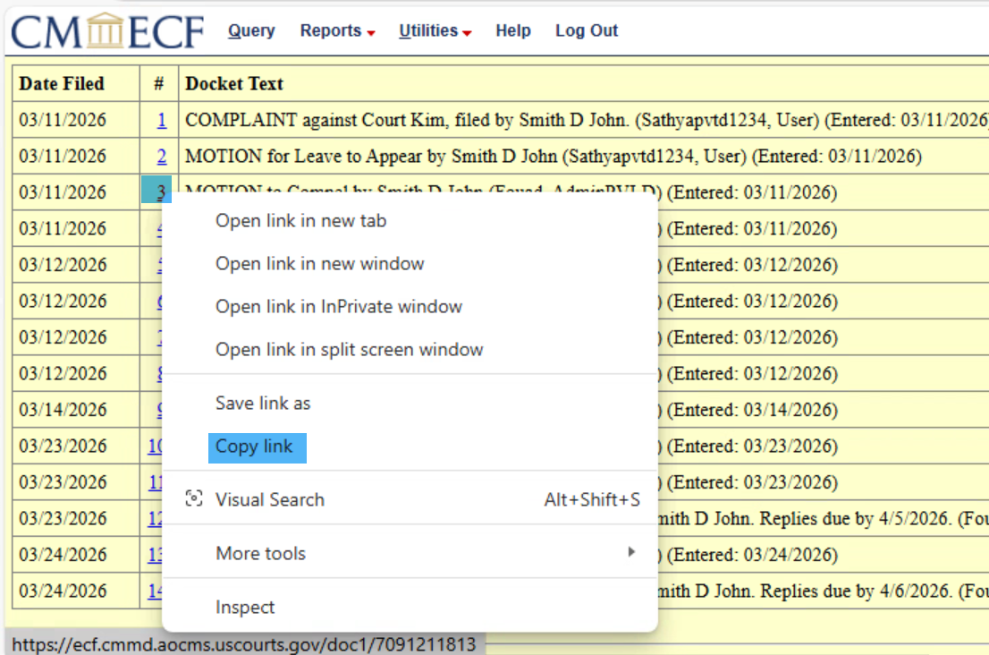

Appellate – Docket Report.
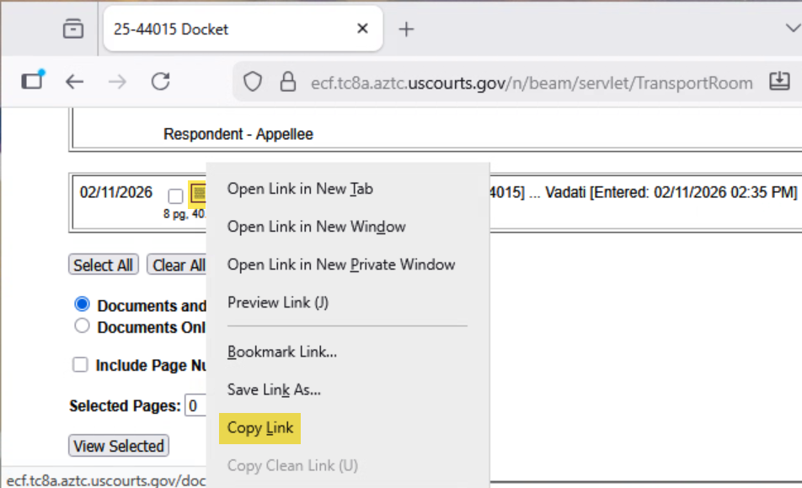

- In Microsoft Word, open the document and highlight/select the citation text that will become the hyperlink.
- Click Insert on the toolbar and select Link → Insert Link → Insert Hyperlink
- The Insert Hyperlink window opens. Paste the URL into the Address field with Ctrl+V:

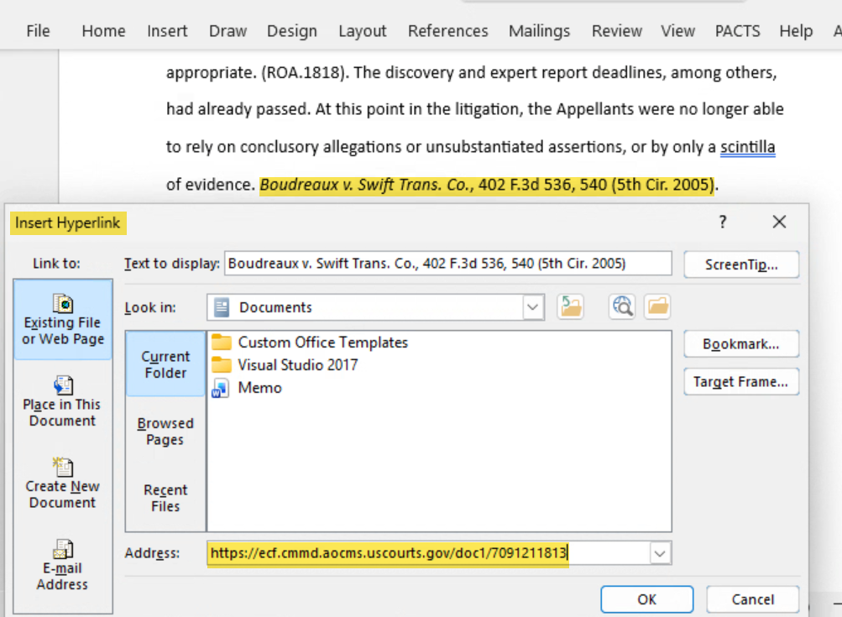
- To link to a specific page in the target document, append “?page=”, followed by the page number, to the end of the URL in the Address field. For example:

https://ecf.cmmd.aocms.uscourts.gov/doc1/7091211813?page=13

- Click OK. The hyperlink text is now underlined and blue. Save the Word document.
- Convert the Word document to PDF using Adobe Acrobat to preserve hyperlinks.
Important: Do not use the Word “Print to PDF” option — hyperlinks will not be preserved. You must use Adobe Acrobat to convert.
Option A — Save As PDF from Word (if available).
Option B — Adobe Acrobat: Create PDF from File
- Save and close the Word document.
- Open Adobe Acrobat and select File > Create PDF > From File.... Navigate to your saved Word file, select it, and click Open. The document will be converted with hyperlinks intact.
- When conversion is complete, save and close the Acrobat PDF file.

- Docket an event in CM/ECF and upload the PDF file you created to the docket entry as usual.

3. Creating Hyperlinks between Documents Filed in the Same Event
It is possible to link two or more documents being filed in the same docketing event (e.g., a hyperlink in the main document pointing to an attachment). Because the referenced document has not yet been filed in CM/ECF, the link initially points to the file on your local PC or server. When the documents are filed, the link is automatically converted to a CM/ECF URL.
Step-by-Step Example using Microsoft Word and Adobe Acrobat:
- Create the secondary Word document (e.g., the attachment) and save/convert it to PDF.
- In Microsoft Word, open the main document (e.g., the one that will contain the hyperlink to the secondary document) and highlight/select the citation text that will become the hyperlink.
- Click Insert on the toolbar and select Link → Insert Link → Insert Hyperlink.
- In the Insert Hyperlink dialog, navigate to the folder containing the secondary document, then highlight/select the PDF file. The selected filename appears in the Address field:

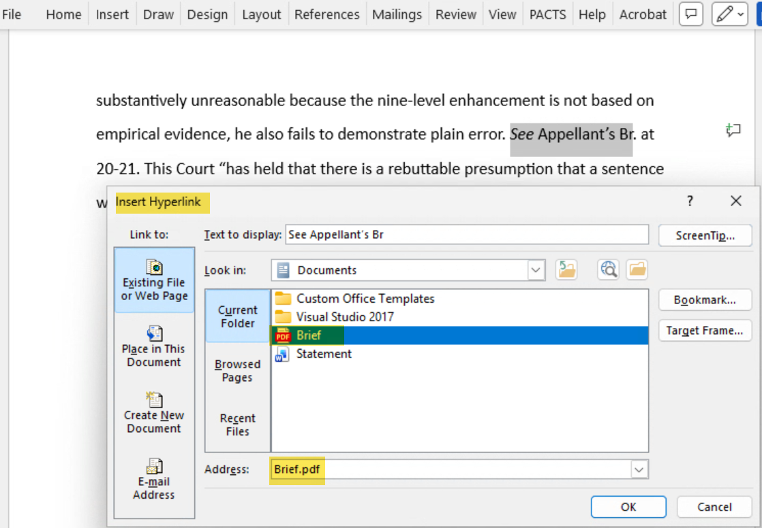

- To link to a specific page within the document, append “?page=”, followed by the page number, to the end of the filename in the Address field. For example:

Brief.pdf?page=5

- Click OK. The hyperlink text will be underlined. Save the Word document.
- Convert the main Word document to PDF using Adobe Acrobat (see Step 9 in Section 2 above).
- Docket an event in CM/ECF and upload the main document and attachment as usual. CM/ECF will automatically convert the local file paths to CM/ECF URLs.

